SOCIOECONOMIC ATLAS OF THE ABORIGINAL COMMUNITIES OF QUÉBEC: A WEB-ATLAS DEVELOPED WITH SCALABLE VECTOR GRAPHICS, C# AND ASP.NET

Philippe Apparicio and Carole Lévesque

Philippe_Apparicio@UCS.INRS.Ca,¹ Carole_Levesque@UCS.INRS.Ca²
¹ Spatial Analysis and Regional Economics Laboratory ² DIALOG – Le réseau québécois d’échange sur les questions autochtones
INRS Urbanisation, Culture et Société

3465, rue Durocher

Montréal (Québec) H2X 2C6

CANADA
Abstract
In Canada, access to and appropriate use of data on Aboriginal communities is an important issue. In this context, the Socioeconomic Atlas of the Aboriginal Communities of Québec (Canada) was developed by the DIALOG cluster—Le réseau québécois d’échange sur les questions autochtones—and the Spatial Analysis and Regional Economics Laboratory in order to provide information to community members, social policy makers and researchers. This atlas, which contains 120 web-maps, is based on a customized compilation of data from Statistics Canada and Indian and Northern Affairs Canada.
Recent developments in interactive and dynamic cartography and the development of Internet technologies have led to a significant increase in the number of interactive atlases on the Internet. With client/server technologies and vector formats for the Internet, it is now possible to deploy rapidly interactive web-atlases. For example, with Scalable Vector Graphics (SVG), one can quickly develop interactive and dynamic mapping functions and thus high quality and interactive web-maps. Moreover, the now well-recognized advantages of web-atlases include their “cost efficiency, flexibility and timeliness, opportunities for active learning and World-wide connectivity” (Togurson and Blinnikov, 2003).
The aim of this paper is to describe a simple and effective approach that uses C#, ASP.Net and SVG to produce interactive atlases on the Internet such as the Socioeconomic Atlas of the Aboriginal Communities of Québec. This approach is extremely useful for two reasons: the cartographic production is very simple and fast, and the development of interactive and dynamic mapping functions is greatly facilitated, is almost unlimited, and can be adapted to the needs and knowledge of the user.
Key words: Atlas, interactive cartography, SVG, web-maps, web cartography.

INTRODUCTION
For the past ten years or so, we have been seeing more and more electronic atlases on the Internet—whether national, regional, metropolitan or thematic in focus (Kraak, 2001; Richard, 1999)—that is, sites including a series of maps with some degree of interactivity. Recent developments in interactive and dynamic cartography and advances in Internet technologies have largely fostered this increase in the number of atlases on the Internet, which are thus responding to the growing demand for geographic information on this medium (Taladoire, 2003; Van Elzakker, 2001 a and b). Moreover, compared with atlases on paper and multimedia (on CD-ROM or DVD), web-atlases have several advantages (which is another reason for their growing numbers): 1) low production costs; 2) the possibility of including interactivity and thereby facilitating map analysis; 3) considerable flexibility in the updating of and adding to maps; and 4) wider dissemination, via the Internet (Togurson and Blinnikov, 2003).
Today, there are so many web-atlases that it is impossible to draw up a complete list of them. A recent addition to this list is the Socioeconomic Atlas of the Aboriginal Communities of Québec (http://www.reseaudialog.ca/rub5.asp?rub=5), the result of a close collaboration between two Québec research groups: the DIALOG cluster—Le réseau québécois d’échange sur les questions autochtones—and the Spatial Analysis and Regional Economics Laboratory (SAREL).
The aim of this paper, which is both descriptive and methodological, is to describe how this atlas was made operational, in focusing especially on its development context, the deployment model on which it is based—that is, on Scalable Vector Graphics (SVG), C# and ASP.Net—and the interactive mapping functions that it includes.

1. THE DEVELOPMENT CONTEXT FOR THE ATLAS: THE DIALOG CLUSTER
DIALOG is an interuniversity, inter-institutional, cross-disciplinary and international cluster created in 2001 and based in Québec (Canada) at Institut national de la recherche scientifique (an academic branch of the Université du Québec). This cluster brings together more than one hundred and fifteen people—researchers, students and collaborators—from universities and Indigenous organizations and communities, who carry out their work in Québec, Canada, the Americas, Europe and Asia. These diverse actors share the objectives of promoting, disseminating and renewing research relating to Indigenous peoples. DIALOG also works closely with 22 partner institutions: 6 universities in Québec and Canada, 7 Québec Indigenous organizations, 6 academic research groups in Québec and 3 community organizations or non-governmental organizations in Québec, Mexico and Chile.
DIALOG serves as a forum that fosters and supports opportunities for meeting, discussion, resourcing and partnership between the academic and Aboriginal milieus; it is a place for reflection and a platform for the development, deepening and renewal of knowledge. As a research cluster, it encourages a renewed questioning of research relating to Indigenous peoples by emphasizing a transcultural and cross-disciplinary approach, promoting situated, reflexive and interactive research practices, and making the co-production of knowledge with Aboriginal peoples one of its main objectives. Finally, DIALOG offers to its members, the scientific community, Indigenous organizations and communities and the general public relational and interactive data banks designed to highlight and promote scientific work relating to Aboriginal peoples. It is in this context that the Socioeconomic Atlas of the Aboriginal Communities of Québec was designed and tested out.

In Québec, there are 54 Aboriginal communities, including 39 North American Indian communities and 15 Inuit communities. The North American Indian communities are in turn distributed within ten First Nations: Abenakis, Algonquins, Atikamekw, Crees, Huron-Wendats, Innus (Montagnais), Malecites, Mohawks and Naskapis. Given this diversity, a web-atlas is clearly a tool that is especially well adapted to the sharing and dissemination of information relating to all of these 54 Aboriginal communities.
Although there are today many different technological solutions facilitating the deployment of atlases on the Internet, the development of a web-atlas on the Aboriginal communities of Québec was still a significant challenge, as it had to satisfy the following objectives:
- it had to be possible to include varied and at times unavailable data sources for all 54 communities;
- the content of the atlas had to be easily extensible, in terms of the themes, data and number of maps;
- most users are not geographers or cartographers, so that interactive functions had to be implemented to make it easier to interpret the maps;
- users’ profiles vary widely: members of Aboriginal communities, representatives of Aboriginal organizations, public decision makers, researchers and students in the DIALOG cluster coming from very different disciplinary fields. The atlas’s navigation and exploration functions thus had to be adapted to these different profiles so that each user could properly make use of the atlas’s analytical potentialities.

2. THE DEPLOYMENT MODEL FOR THE ATLAS, BASED ON SVG, ASP.NET AND C#
The deployment model for the Socioeconomic Atlas of the Aboriginal Communities of Québec presented here is based on C# programming language, in order to use three technologies: SVG, ADO.Net and ASP.Net. This model has in fact already been used to put four other atlases developed by the Spatial Analysis and Regional Economics Laboratory on-line.
2.1 Use of SVG, ASP.Net and ADO.Net with C#
SVG is a 2D vector format for the Internet based on XML and developed by the W3C consortium (http://www.w3.org/TR/SVG). It has many advantages, on both the design and graphic levels (Danzart et al., 2003; Neumann and Winter, 2003). Recently, Danzart et al. (2003), who compared three solutions that are used to create dynamic and interactive maps—SVG, Flash and MPEG-4—concluded that SVG is the most effective solution for the deployment of dynamic and interactive mapping applications and thus of atlases on the Internet.
In terms of design, SVG is a free language; in other words, it can be used without charge. It is also a standard that takes into account W3C methods, especially CSS (Cascading Style Sheets), DOM (Document Object Model), SMIL (Synchronized Multimedia Integration Language), XSL and XLST (Extensible Stylesheet Language Transformations), and that is supported by the most common Internet technologies (HTML, ASP, ASP.Net, JSP, PHP, etc.). This interoperability thus makes it much easier to develop SVG-based applications.
On the graphic level, SVG integrates three types of objects: drawing elements (line, polyligne, polygon, circle, rectangle and ellipse, cubic and quadratic Bézier curves), images and text. It is much easier to manipulate these graphic elements since SVG elements are objects that can easily be given stylistic properties and attributes (line thickness, colour, visibility, transparency, etc.). SVG elements can also be grouped, transformed (rotation, scaling, etc.) and animated. Finally, thanks to DOM (Document Object Model), SVG files can integrate internal or external script (JavaScript), so that one can quickly and effectively develop the interactive functions associated with the SVG elements. One can also generate graphic elements using these scripts.
C# language, which operates with the Microsoft .Net platform, has many similarities with C++ and can be used to rapidly deploy Windows and Web applications (Watson, 2001). The Web applications are based on ASP.Net (client/server technology) and ADO.Net for access to data on a server. The coupling of C#.Net and ASP.Net makes it easier to set up client/server web sites for several reasons. First, ASP.Net includes Web forms that are very similar to classic Windows forms, so that one does not have to use the at times very fastidious HTML. The most obvious advantage of ASP.Net is that it represents a real object programming language generating HTML, DHTML or XHTML pages; so that one no longer has a code combining several technologies and interpreted languages—ASP, JavaScript, VBScript, CSS, DOM, HTML—that are sometimes so hard to read and maintain. Finally, ASP.Net can be programmed with any language supported by the .Net platform (C#, Visual Basic.Net, C++, J#).
2.2 Deployment Model
The deployment model for the interactive web-atlas is shown in Figure l. It includes two phases: Data Preparation and C# Web Application, that is, the computer programming of the site as such.
The first data preparation task is to structure and integrate all of the data needed to build the maps within a database software (Access, SQL Server, Oracle, etc.). This information is of two kinds: attributive data associated with spatial entities; and the map features, that is, map and legend titles, name(s) of the variable(s) used, types of cartographic representation (proportional circles, graduated symbols, graduated colour, etc.), class boundaries and colours, and the analytical text associated with the map. To make it easier for the cartographer who has to enter all this information, a data entry form has been created for this purpose.
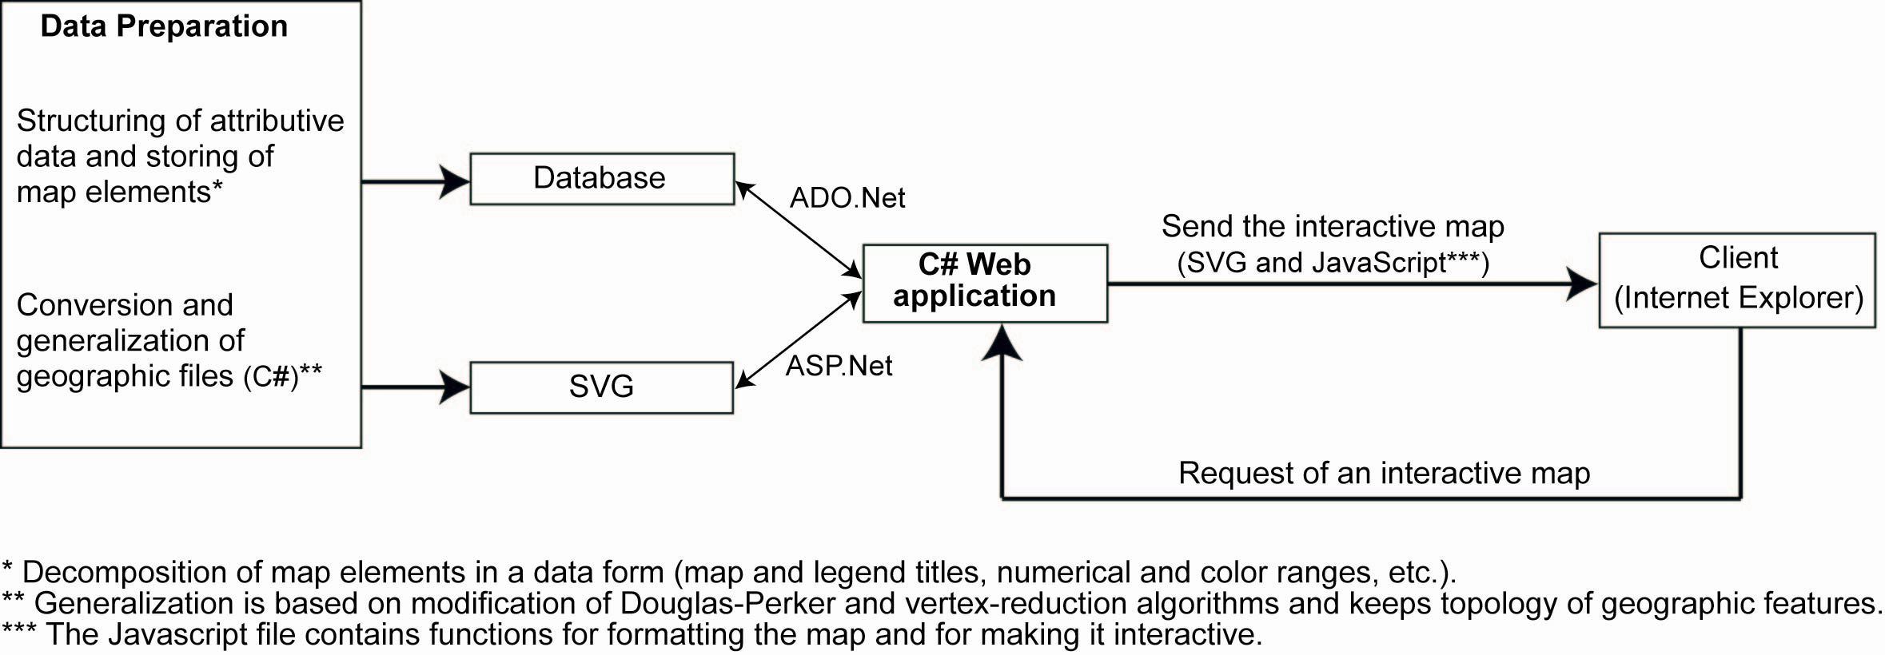
Figure 1. Deployment Model
Still in the data preparation phase, the geographic file has to be generalized and converted to SVG format, if required. To satisfy these two objectives, we developed a C#.Net application for the conversion of shapefile (ESRI) to SVG format by applying (or not applying) a level of generalization of the geographic information (Petkevitch and Apparicio, 2006). Moreover, generalization is a process which is often necessary to make the SVG file a reasonable size that does not limit the ease of Internet navigation. Let us note in passing that the generalization algorithms implemented in this application—the Douglas-Peucker (1973) and vertex-reduction algorithms (Hershberger and Snoeyink, 1992)—have been modified to keep the polygon topology.
The second phase of the deployment model—programming of the site—is carried out in C#.Net and is based on ADO.Net technology for access to and querying of the database, on ASP.Net technology for the creation of web pages, and on JavaScript code for formatting the map and making it interactive. More concretely, when the client requests an interactive map, the C# web application accesses and reads the attributive and geographic data from the database using ADO.Net. Then, the application uses ASP.Net to write a series of global variables in the JavaScript file, which contains formatting and interactive mapping functions, and finally, it sends the JavaScript file and SVG file to the client.

3. FUNCTIONS OF THE ATLAS
The Socioeconomic Web-Atlas of the Aboriginal Communities of Québec includes 121 maps grouped by themes and according to the two data sources used (Indian and Northern Affairs Canada and Statistics Canada). Due to the very diverse profiles of the users of the atlas that we mentioned earlier, we developed two navigation modes: a simple mode and a second, more advanced mode that includes more interactive functions (Figure 2).
The atlas is made up of three types of elements: elements for navigating through the atlas, map formatting elements and interactive mapping functions.
With the first navigation element identified by the symbol ① in Figure 2, the user selects and activates the various categories of the atlas using the dropdown menus. The content of these menus is generated automatically with ASP.Net, using information entered in the database. This makes it easier to modify and extend the content of the web-atlas. For example, to create a new category in the atlas, one simply has to add a record in the database, and then enter the title of the category and the information for the corresponding map. The menu bar (② in Figure 2) can be used to activate a number of functions: viewing of the analytical text or a table accompanying the map, printing or saving the map in jpeg and changing from French to English or vice versa.
Still in Figure 2, symbols 3 to 6 correspond to map formatting elements: ③ map title, ④ legend building, ⑤ attribution of proportional circles or graduated colours, and ⑥ building of a table linked to the map. In the advanced navigation mode, one also finds a histogram and descriptive statistics linked to the map (⑦ et ⑧). It is important to note that this formatting is done from the client’s workstation with JavaScript code external to the SVG file and not by using the server’s resources, which makes the application even faster.
To make it easier to analyze the maps, several interactive mapping functions have also been incorporated into the web-atlas, including navigation functions on the map (zoom in and out, predefined zooms, full extent, pan, distance between two points) and an information tool (see symbols and in Figure 2). Other functions are designed to facilitate exploration of the data: dynamic links between the map and the graph and legend, displaying of the name of the community and the value of the corresponding variable in a table as well as the First Nation to which the community belongs by moving the mouse to the community in question.
CONCLUSION
Vector formats like the SVG standard represent the most recent and most successful solutions for the deployment of interactive and/or dynamic atlases (Danzart et al., 2003). Our deployment model for interactive web-atlases based on a vector format for the Internet (SVG) and on client/server technologies (ADO.Net and ASP.Net) is very effective for two main reasons. On the one hand, mapmaking is made much easier because the maps are automatically formatted by programming and by using information entered in a database (map and legend titles, numbers, colours and boundaries of classes, etc.). These functions foster greater flexibility in modifying existing maps or adding new maps. And on the other hand, with SVG, one can easily operationalize certain interactive web-mapping concepts such as functions for data exploration, for navigation or personalization of the map and, finally, for designing several modes of navigation and interactivity based on the type of users of the atlas.
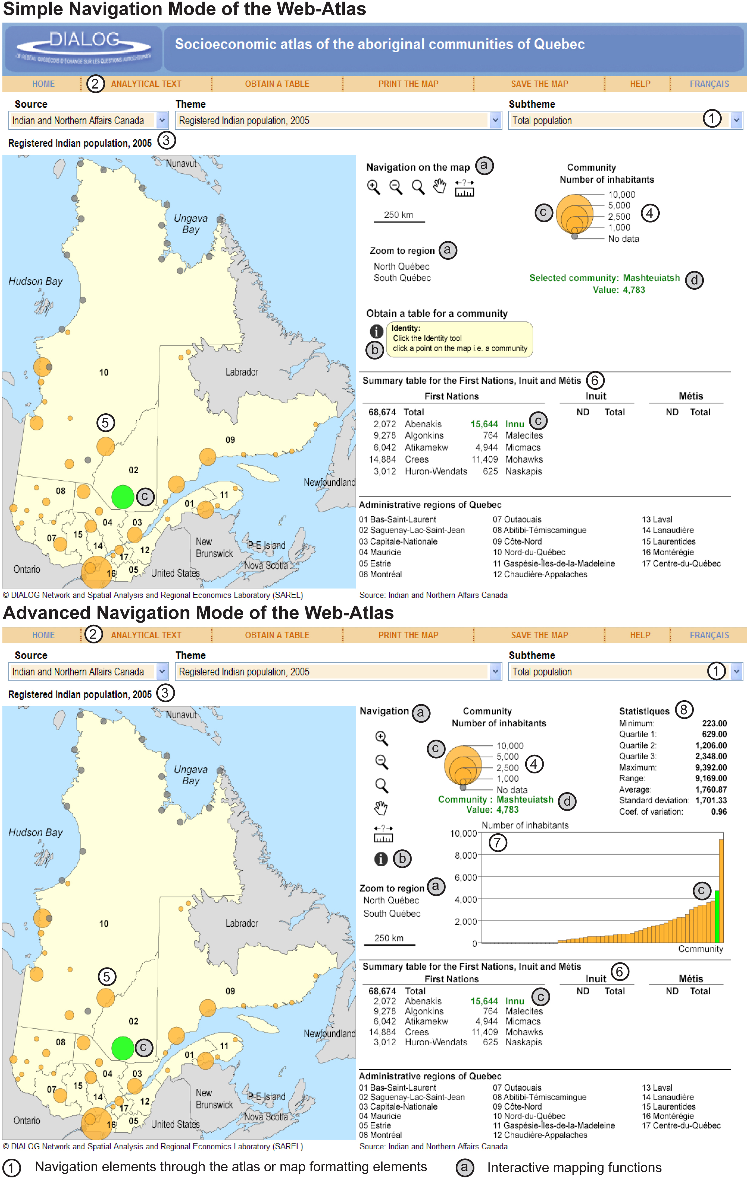
Figure 2. Socioeconomic Web-Atlas of the Aboriginal Communities of Québec
References
Cartwright W., 2003, "Maps on the Web", in Peterson M. P. (ed.), Maps and the Internet. Published on behalf of the International Cartographic Association, Amsterdam, London, Elsevier.
Danzart B. S., Moissinac J.-C., Poitier C., 2003, "Standards pour la cartographie animée sur Internet", Revue internationale de géomatique, Vol.13, No.1, 49-68.
Douglas D., Peucker T., 1973, "Algorithms for the reduction of the number of points required to represent a digitized line or its caricature", Canadian Cartographer, Vol.10, No.2, 112-122.
Hershberger J., Snoeyink J., 1992, "Speeding Up the Douglas-Peucker Line-Simplification Algorithm", Proceedings of the 5th Symposium on Data Handling, 134-143.
Kraak M. J., 2001, "Web maps and atlases", in Kraak M. J., Broon A. (eds.), Web cartography. Developments and prospects, New York, Taylor & Francis.
Neumann A., Winter A. M., 2003, "Webmapping with Scalable Vector Graphics (SVG): delivering the promise of high quality and interactive web maps", in Peterson M. P. (ed.), Maps and the Internet. Published on behalf of the International Cartographic Association, Amsterdam, London, Elsevier.
Petkevitch V., Apparicio P., 2006, "Converting and generalizing maps into compact Scalable Vector Graphics format," Les Inédits (Document de recherche / Working paper), Montréal, INRS-UCS.
Richard D., 1999, "Web atlases of Switzerland", in Cartwright W., Peterson M. P., Gartner G. (eds.), Multimedia cartography, Berlin, Springer.
Taladoire L., 2003, "Editorial", Revue internationale de géomatique, Vol.13, No.3, 93-106.
Torguson J. S., Blinnikov M. M., 2003, "From maps to student interaction: creating a web-based student Atlas of Russia", in Peterson M. P. (ed.), Maps and the Internet. Published on behalf of the International Cartographic Association, Amsterdam, London, Elsevier.
Van elzakker C. P. J. M., 2001a, "Use of maps on the Web", in Kraak M. J., Broon A. (eds.), Web cartography. Developments and prospects, New York, Taylor & Francis.
Van elzakker C. P. J. M., 2001b, "Users of maps on the Web", in Kraak M. J., Broon A. (eds.), Web cartography. Developments and prospects, New York, Taylor & Francis.
Watson K., 2001, Maîtrisez C#, Paris, Worx Press and CampusPress.

For example, the researchers come from the following disciplines: anthropology, archaeology, communications, criminology, law, economics, education, environmental studies, tourism studies, geography, management and administration, history, linguistics, social and preventive medicine, psychology, political science, sociology and social work.
Apparicio, P., M. Polèse, J. Ades, P. Rivet, I. Angoa, J. Chaffee Hopper and M.A. López, 2006, Atlas de la Sierra Nororiental de l’État de Puebla, Mexique (http://atlaspuebla.inrs-ucs.uquebec.ca). Apparicio, P., V. Petkevitch, M. Polèse, P. Rivet, I. Angoa, J. Chaffee Hopper and M.A López, 2005, Atlas socioéconomique de l’État de Puebla, Mexique (http://atlassn.inrs-ucs.uquebec.ca). Apparicio, P., J. Mongeau, V. Petkevitch and M. Radice, 2004, Atlas de l’immigration de la RMR de Montréal en 2001 (http://atlasim2001.inrs-ucs.uquebec.ca). Apparicio, P., V. Petkevitch, J. Tremblay, Y. Martineau and G. Grégoire, 2004, Atlas électronique de la zone Métropolitaine de l’emploi de Montréal : de l’organisation spatiale du marché du travail à l’organisation spatiale des déplacements domicile-travail (http://www.atlas-zme.qc.ca/).
This application can be downloaded free of charge from the SAREL (LASER) web site (http://laser.ucs.inrs.ca/).

